P3.1 Pre-Unit Quiz

- Which is the best definition for resultant force? [1]
Tick ( ) one box.
- Equal forces acting in opposite directions | 
- The overall effect of all the forces acting on an object
- The biggest force acting on an object

The diagram below shows some of the forces acting on a car. Use this diagram to answer Questions 2 to 4.
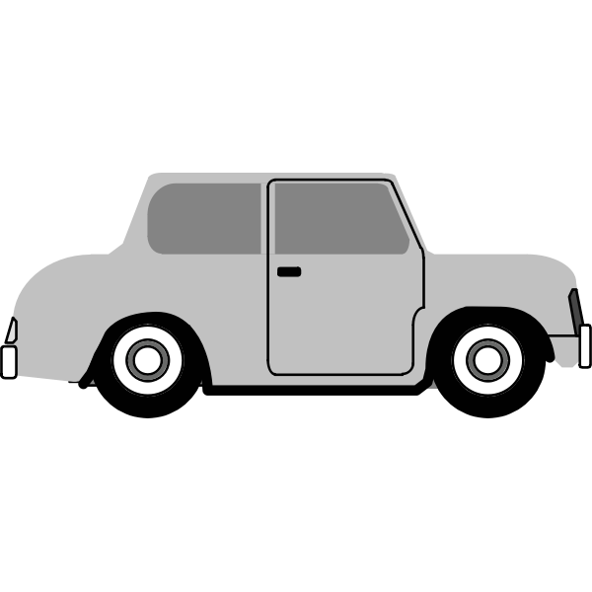
2000 N
800 N

- What is the size of the resultant force on this car? [1]
Tick ( ) one box.
- 1200 N left
- 1200 N right
- 2800 N

- Which option best describes the motion of the car? [1]
Tick ( ) one box.
- The car would be stationary
- The car would be moving at a constant speed towards the right
- The car would be accelerating towards the right

- The backward force increases until it is also 2000 N. Which option
best describes the new motion of the car? [1]
Tick ( ) one box.
- The car would be moving at a constant speed towards the right
- The car would slow down
- The car would have stopped

- Which option correctly shows how you would calculate the speed of a car that travelled 1 km in 1 minute? [1]
Tick ( ) one box.

- Speed = 1 km
1 minute
- Speed = 1000 m
60 seconds
- Speed = 1000 m x 60 seconds

Use the following distance-time graph to answer Questions 6 to 9.

- When is the object not moving? [1]
Tick ( ) one box.
- Between 0 and 5 seconds
- Between 5 and 10 seconds
- Between 15 and 30 seconds

- When is the object moving fastest? [1]
Tick ( ) one box.
- Between 5 and 10 seconds
- Between 10 and 15 seconds
- Between 15 and 30 seconds

- What is the total distance travelled by this object? [1]
Tick ( ) one box.
- 40 m
- 35 m
- 130 m

- Which is the correct SI unit for speed? [1]
Tick ( ) one box.
- m/s
- mph
- km/h

- A runner runs 1500 m in 500 seconds before resting for 50 seconds. Then she runs another 500 m in 250 seconds. What is her average speed for the whole run? [1]
Tick ( ) one box.
- 3 m/s
- 2.5 m/s
- 2.67 m/s

